INVITATION TO QUOTE
for the provision of
SouthWest Rural Community Energy Fund (RCEF) Programme Evaluation

Supply the South West reference number: DN 635671

Published – 30.09.2022

Submission by: 12:00 midday, 12 October 2022

Procurement LEAD – emil.cirica@westofengand-ca.gov.uk

West of England Combined Authority Information

The West of England Combined Authority is creating a better, greener future for people who live and work in the region.

It is improving peoples’ lives:
- helping residents secure decent jobs and homes they can afford.
- tackling climate change and the ecological emergency.
- providing access to skills and training.
- improving transport and the places people live, work and visit.
- supporting businesses to succeed.

The West of England Combined Authority is creating a region to be proud of.

The West of England region:
- has a diverse population of more than 1.1million people.
- boasts a highly skilled workforce and one of the highest levels of graduates in the UK.
- is home to innovative and creative businesses
- has an economy, built on strong foundations, worth over £40bn a year.

It is a region which competes on global scale. A region where ideas flourish and businesses grow.

www.westofengland-ca.gov.uk

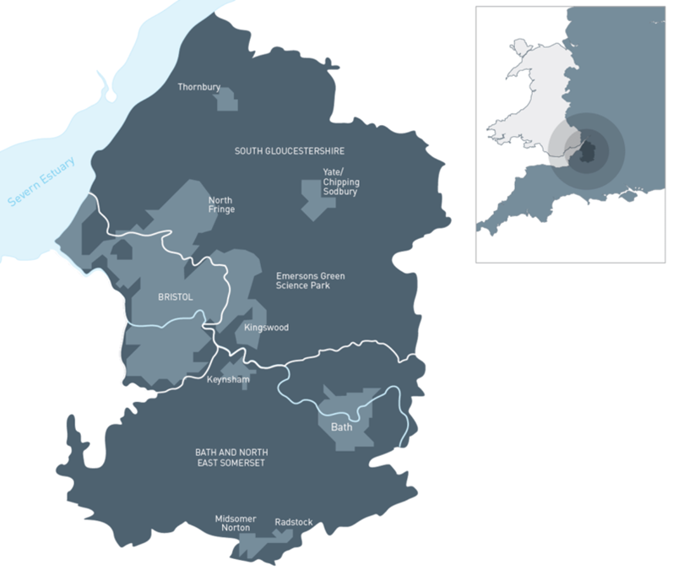
Form of Quote Letter

Invitation to tender for: The Provision of South West Rural Community Energy Fund (RCEF) Programme Evaluation

Important Note: Where a Bidder is a consortium, this Form of Quote Letter must be signed by the authorised signatories of all members of the consortium. Each signatory must confirm his/her name and title as well as the full name and address of the member of the consortium on whose behalf he/she is signing.
To: West of England Combined Authority.
We the undersigned, having read the draft Contract and Specification do hereby offer to complete the supply of services required to be performed in the carrying out of the above contract in accordance with the above documents, to the criteria as appended to this letter.
We understand that the Authority is not bound to accept the lowest or any quote and will not pay any expenses incurred by us in connection with the preparation and submission of this Tender.
We agree that my/our quotation remains open for consideration for a period of 90 days from the date fixed for submission of quotation. We declare that the insurance specified in the draft Contract is currently maintained by us.
We confirm that we have the capability and resources to meet all requirements of the draft Contract and the Specification in terms of quality, cost, and time.
Signed:
Designation:
(Duly authorised to sign tenders and give such certificate for and on behalf of:
Tenderer
Date:
Address:

INDEX

Section 1 – THE REQUIREMENT

  - Introduction
  - What will the project deliver?
  - Specification
  - Term of Contract
  - Contract Award
  - Contract Value
  - Assessment Criteria
  - Procurement Timetable

Section 2 – INSTRUCTIONS TO SUPPLIERS

2.1 E-Quote System
2.2 Register Intent or Opt Out
2.3 Preparation of Quote
2.4 Price Schedules
2.5 Other Documents or Supporting Evidence
2.6 Submission Deadline
2.7 Quote Validity
2.8 Communication
2.9 Confidentiality
2.10 Disclaimer
2.11 Freedom of Information Act
2.12 Transparency
2.13 Procurement Timetable
2.14 Required Documents

Section 3 – QUESTIONNAIRE

A Notes for Completion
B Questionnaire

Section 4 – EVALUATION AND AWARD

5.1 Evaluation (Part 1 & Part 2)
5.2 Recommendation
5.3 Contract Award

SECTION 1 – THE REQUIREMENT

  - Introduction

RCEF is a £10 million programme funded by the Department of Business Energy and Industrial Strategy (BEIS) offered to community energy groups on the premise that support provided for pre-development costs and robust planning applications will enable latent demand for renewable energy investment to be unlocked. The intention is that it will address both the financial and knowledge barriers to communities investing in renewables. Apportioned to each Local Energy Hub in England, the Southwest was allocated just over £172000. Programme delivery and closedown will complete in March 2023. Key objectives include:

- Supporting rural communities – by helping them to maximise the income generating potential of renewable energy and put this to work locally
- Making progress against the Government’s target to increase renewable energy generation, and promote community-owned renewable schemes
- Promoting rural growth and job creation – to enable communities to access the economic benefits associated with renewable energy schemes.

Eligible organisations are required to be a legal entity providing benefit to the community and belonging to a rural settlement of fewer than 10,000 residents. Under the Hub-delivered scheme, organisations could apply for up to £40k for stage 1 (feasibility) and £100k for stage 2 (planning) projects.

1.2 What will the Project deliver?

The South West Net Zero Hub (previously Energy Hub) is seeking consultants with a strong knowledge and experience of evaluating Community Energy projects and local government programmes to provide an independent evaluation of the Rural Community Energy Fund (RCEF) programme delivered by the South West Net Zero Hub.

The evaluation will review governance and delivery of the programme alongside enabling activities to engage communities and the resulting pipeline of low carbon projects. The study will explore the opportunities, challenges and regional circumstances encountered within the Hub area to provide a nuanced understanding of impact.

Funding for this evaluation has been provided by BEIS, therefore BEIS will be a recipient of the final outputs, along with the Net Zero Hub’s Management Board, and findings will be used to inform future programme priorities and direction.

The successful provider should be aware that an overarching Evaluation of Hub activity is taking place in parallel and will be developing a common approach/methodology for counting carbon across the Hubs. The preference is for the RCEF evaluation to reflect on this in undertaking the review.

1.3 Specification

Rural Community Energy Fund Programme Evaluation

Contents
1. Contents 1
1. Specification / Project Brief 2
1.1. Summary 2
1.2. Background: Local Net Zero Hub Programme England 2
1.3. Background to RCEF 2
1.3.1. Key Performance Indicators 3
1.3.2. RCEF Logic Chain 4
1.3.3. RCEF Co-benefits 4
2. Project Objectives 6
2.1. Aims 6
3. Scope of Services 6
3.1. Project Milestones 7
3.2. Tender Scoring Criteria 8
4. ANNEX ONE – Rural Community Energy Fund KPIs 9

Specification / Project Brief

Summary

The South West Net Zero Hub (previously Energy Hub) is seeking consultants with a strong knowledge and experience of evaluating Community Energy projects and local government programmes to provide an independent evaluation of the Rural Community Energy Fund (RCEF) programme delivered by the South West Net Zero Hub.
The evaluation will review governance and delivery of the programme alongside enabling activities to engage communities and the resulting pipeline of low carbon projects. The study will explore the opportunities, challenges and regional circumstances encountered within the Hub area to provide a nuanced understanding of impact.
Funding for this evaluation has been provided by the Department of Business Energy and Industrial Strategy (BEIS). BEIS will be a recipient of the final outputs, along with the Net Zero Hub’s Management Board, and findings will be used to inform future programme priorities and direction.
The successful provider should be aware that an overarching Evaluation of Hub activity is taking place in parallel and will be developing a common approach/methodology for counting carbon across the Hubs. The preference is for the RCEF evaluation to reflect on this in undertaking the review.

Background: Local Net Zero Hub Programme England

The BEIS Local Net Zero programme (previously the Local Energy Programme) supports local authorities and communities in England to play a leading role in decarbonisation and clean growth.
The programme was announced in 2017 as part of the Clean Growth Strategy. Funding was provided for the creation and support for five Local Net Zero Hubs (previously known as the Local Energy Hubs). The Hubs were established to promote best practice and support local authorities to develop net zero projects up to the point of commercial investment.
The original objectives, as set out in the Local Energy Capacity Support Memorandum of Understanding in 2017, are:
- Increase number, quality and scale of local energy projects being delivered.
- Raise local awareness of opportunity for and benefits of local energy investment.
- Enable local areas to attract private and/or public finance for energy projects.
- Identify working model for teams to be financially self-sustaining after first two years.

Background to RCEF

The original RCEF programme, jointly funded by government departments DEFRA and BEIS and delivered by WRAP across England, was a £15 million grant and loan funding scheme available to support early-stage community energy projects in rural areas to provide economic and social benefits. The programme was operational between June 2013 and September 2018 but had low take -up.
The unallocated RCEF budget and additional funding, totaling £10 million, was subsequently apportioned to each Local Energy Hub in England to deliver a new RCEF programme. To encourage take-up, KPIs were altered and the scheme became grant-based only. Programme delivery and closedown will complete in March 2023.

RCEF funding is offered on the premise that support provided for pre-development costs and robust planning applications will enable latent demand for renewable energy investment to be unlocked. The intention is that it will address both the financial and knowledge barriers to communities investing in renewables. Key objectives include:

- Supporting rural communities – by helping them to maximise the income generating potential of renewable energy and put this to work locally
- Making progress against the Government’s target to increase renewable energy generation, and promote community-owned renewable schemes
- Promoting rural growth and job creation – to enable communities to access the economic benefits associated with renewable energy schemes.

Eligible organisations are required to be a legal entity providing benefit to the community and belonging to a rural settlement of fewer than 10,000 residents. Under the Hub-delivered scheme, organisations could apply for up to £40k for stage 1 (feasibility) and £100k for stage 2 (planning) projects.

Key Performance Indicators

STAGES 1 & 2
  - Project name
  - Organisation type
  - Amount granted
  - Technologies used on site
  - Number of new rural communities engaged*
  - CO₂ savings

STAGE 2 Only*
  - Megawatts (MW) planned
  - Further investment secured
  - Jobs created
  - Volunteers engaged
  - Match funding secured
  - Community support provided
  - Number of completed case studies
  - CO₂ savings
*Particularly for smaller scale projects value to a place based solution that meets the needs of the local population is to be considered, alongside innovative combinations of technologies and approaches to resolving local energy challenges.

RCEF Logic Chain
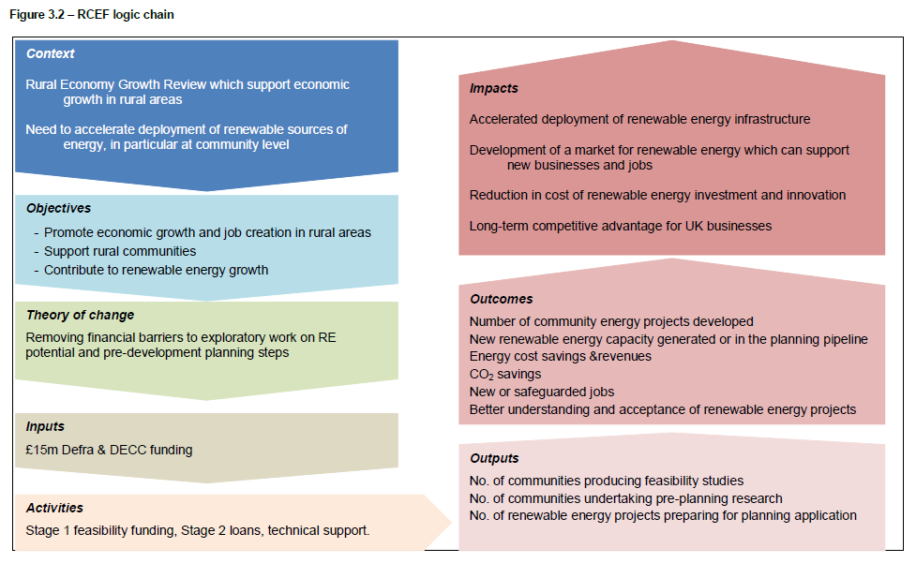

RCEF Co-benefits
The objectives, outputs, outcomes and impacts for the RCEF were established in the original business case for the RCEF and presented as Social Return on Investment, using a social theory of change method. See below:
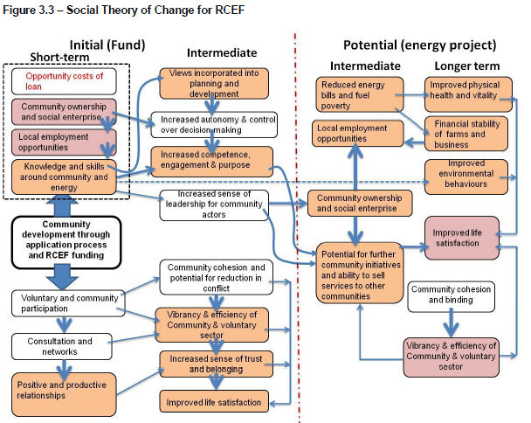
Social outcomes resulting from the use of Rural Community Energy Funds were expected to include:
- Voluntary and community participation
- Community cohesion and binding
- Vibrancy and efficiency of community and voluntary sector

Project Objectives
The evaluation should provide an assessment of the economic and social benefits of the Rural Community Energy Fund programme, along with the potential or likely carbon and wider environmental impacts on communities.

Aims
- To review delivery of the Rural Community Energy Fund programme against the original premise of unlocking investment for renewable energy technology. Where possible, provide evidence of early outcomes and impacts against the original RCEF objectives (see above).
- To review the effectiveness of the administration and delivery model (including any associated enabling activity) in mobilising community energy activity and explore any challenges or barriers faced.
- To explore any difficulties encountered by community organisations in delivering their RCEF projects and the support or interventions received to overcome them.
- To assess the leverage of private/commercial investment into community projects and provide justified suggestions for how this might be improved.
- To provide evidence-based recommendations to inform future delivery of support for community based local energy projects including the role of community energy in the context of, and in additions to, national decarbonisation policy.

Scope of Services
Activity 1 – Regional Evaluation
The evaluation will seek to answer these key questions:
 | Key questions | Sub-questions
Programme design | Was the selection process robust and effective in ensuring the programme achieved the best outcomes? | Were any opportunities missed?  Were timescales realistic and achievable?
Programme delivery | Has the programme delivered as intended? | Has investment in renewables technologies been unlocked?  What quantified or qualifiable impacts can be attributed to the programme?  What has been the impact of interventions undertaken by the Hub?  What were the reasons for any non-delivery or slippage?
Programme governance | Were appropriate resources in place to safeguard the programme and maximise delivery? | How were risks to the programme managed and mitigated?
Programme impact | What has the programme achieved? | What has happened/ is expected to happen as a direct impact of the programme?  Have there been any additional or unintended benefits of investment?  Did the programme enable additional funding opportunities to be leveraged?  What would have happened in the absence of the investment?  What will be the carbon emissions savings as a result of this programme?
Value for Money | Has the programme provided a positive return on public investment? | Has the expected economic/social value of schemes been realised?  What is the benefit of community energy projects in additional to national decarbonisation policy?
The Hub is keen to explore what future programme management and scheme design for community energy support might look like. This evaluation will provide an evidence base to advocate for and support the prioritisation of future investment activity.
A national meeting of evaluators will take place in the early stages of work where commonalities and differences of approach will be identified.
Evaluations of RCEF programmes from each of five Net Zero Hubs will happen in parallel. Draft reports for all five Net Zero Hubs will be provided at the midpoint and reviewed by BEIS. Feedback will be provided to be reflected in final reports.
The North West Net Zero Hub has been selected to appoint a contractor to provide a national synthesis of the findings, see Activity 2 below. To support this national synthesis work, the team for this evaluation will:
- Provide both the draft and final reports to the NW Evaluation team (in line with deadlines set out below)
- Dedicate three days of resource to support the NW Evaluation team in their work at the end of the evaluation period
The final report may be used by BEIS for further analysis and will be an internal document, not for publication. Background information and data analysis undertaken as part of the evaluation will be handed over as an additional output.

Methodology
This activity is expected to be primarily desk-based research and analysis of available data, significantly augmented by consultation with key stakeholders, including:
- Project sponsors
- Programme administrators
- BEIS RCEF lead

The Hub will make introductions to relevant stakeholders to support the engagement.
Key Outputs
The final report should be supplied as a pdf document, with accompanying summary slides and be formatted to be informative, visually appealing, accessible and public facing.

Budget
The maximum indicative budget available for this project is £30,000 inclusive of all fees and expenses and exclusive of VAT.
Please complete the price submission template to give a breakdown of your costs.

Project Milestones

Indicative timescales to be agreed at project inception are:
All Hubs | (5 weeks)
Target Contract Commencement date: | w/c 27th October 2022
Inception Meeting: | w/c 31st October 2022
National Workshop | 14th November 2022
Draft Regional Report – Milestone 1 | 16th January 2023
Feedback from BEIS review | w/c 23rd January 2023
Final Report Regional– Milestone 2 | 3rd February 2023
Support provided for National Synthesis | 3rd – 24th February 2023
Contract end | 24th February 2023

Tender Scoring Criteria

Tenders will be evaluated Quality (70%) and Price (30%)
Quality

Approach and Methodology [Quality Weighting 40%]
Please provide an outline of the proposed methodology, setting out how you would approach the task of evaluating the value of the Rural Community Energy Fund Programme delivery:
Please include:
- Your proposed methodologies and tools, including how these will be deployed to meet the brief
- Your assessment of any methodological limitations and associated implications for the evaluation
- Your assessment of any opportunities to enhance the scope or depth of the evaluation within the budget and resource available
- Your approach to involving partners, project sponsors and other stakeholders with the research
- An appended outline structure for the evaluation report

Skills and Experience of Key Team Members [Quality Weighting 30%]
Please highlight the relevant skills, experience, knowledge and qualifications of named staff who shall be involved in delivering this project with particular attention to:
- Providing full CVs (not summaries), including position within the organisation and specific relevant experience of working on similar projects
- Identifying specific roles and key assigned tasks within the project,
- Previous work on similar scope/scale independent evaluations of comparable programmes/ activity
- Communication skills, including the ability to write in a concise form and present to stakeholders

Timeliness of delivery & Risk Management [Quality Weighting 20%]
Please detail your robust and credible approach to project and risk management and how you shall ensure this project is successfully delivered within the timescales and parameters of the specification. Your response should include:
- How your proposed strategy will maximise the time and budget available
- Provision of a credible and acceptable project plan, including appended Gantt chart
- Evidence that your organisation has the capacity to mobilise quickly and complete the project
- Description of how you will provide quality assurance and deal with any issues or concerns raised in the course of monitoring contract delivery

Social Value [Quality Weighting 10%]

Please identify how, if successful, your organisation will deliver additional social value aligned with the objectives of the Governments Net Zero Strategy ( https://www.gov.uk/government/publications/net-zero-strategy) within the Hub geography. N.B. This must be activity undertaken over and above delivery of the contract.

ANNEX ONE – Rural Community Energy Fund KPIs
Question | Data currently available | Analysis expected | Additional data needed | Collection methods for additional data
1 | Number of projects delivered Stage 1,  - Project name  - Project location (inc LEP area)  - Organisation type  - Amount granted  - Technologies used on site  - Number of new rural communities engaged | Process evaluation, collation of outputs | Qualitative information re. blockers to delivery of projects | Interviews with groups, officers LA reps or project leads.  Data collection.  Number of case studies completed
2 | Number of projects delivered Stage 2,  - Project name  - Project location (inc LEP area)  - Organisation type  - Amount granted  - Technologies used on site  - Number of new rural communities engaged | Process evaluation, collation of outputs | Qualitative information re. blockers to delivery of projects | Interviews with groups, officers LA reps or project leads.  Data collection. Number of case studies completed
3 | Installed capacity, Energy generation and Carbon savings tCO2e over time (via sources Hubs have used to estimate + proxy info) | Outcomes analysis and quality assurance of savings provided + process evaluation | Qualitative information re. Hub support in overcoming blockers to deliver projects  Quantitative - Energy savings (or increase) kwh by fuel type per project | Interviews with groups, officers LA reps or project leads.  Data collection
4 | Investment and finance breakdowns, leveraged finance/ match funding | Outcomes analysis + process evaluation | Qualitative information re. Barriers to investment and Hub support in overcoming these | Interviews with groups, officers LA reps or project leads.  Data collection
5 | Jobs created,  Volunteers engaged,  Community support provided | Collation of outputs  Enquiries, workshops, webinars, presentations, Events | Qualitative information – social impact, ripple effect | Interviews with groups, officers LA reps or project leads
6 | Completed projects, projects in planning (timeline for completion) | Collation of project status |  | Interview project managers and review Gannt chart
7. | Value of having a lead officer in the region liaising and supporting | Collation of feedback from community groups | Qualitative information – surveys / interviews / workshops | Interviews with groups, officers LA reps or project leads

1.4 Terms of Contract

West of England Combined Authority standard terms and conditions, It is mandatory that the supplier to accept when submit a bid. By submitting a bid the supplier acknowledges the acceptance of Ts and cs.

1.5 Contract Award

ARE THERE ANY ADDITIONAL SPECIFIC CONDITIONS AROUND THE AWARD NOT COVERED IN THE STANDARD SERVICE TERMS OR CONSULTANCY TERMS

1.6 Contract Value
The maximum indicative budget available for this project is £30,000 inclusive of all fees and expenses and exclusive of VAT.

1.7 Assessment criteria

QUALITY | 70%
PRICE | 30%

1.8 Dates – Timetable

All Hubs | (5 weeks)
Target Contract Commencement date: | w/c 27th October 2022
Inception Meeting: | w/c 31st October 2022
National Workshop | 14th November 2022
Draft Regional Report – Milestone 1 | 16th January 2023
Feedback from BEIS review | w/c 23rd January 2023
Final Report Regional– Milestone 2 | 3rd February 2023
Support provided for National Synthesis | 3rd – 24th February 2023
Contract end | 24th February

SECTION 2 – INSTRUCTIONS TO BIDDERS

2.1 E-Quote System
The Authority uses ProContract as its e-procurement system. Assistance in relation to the e-procurement system is available to suppliers via the Supplier Help Icon within the system. Supplier Guidance documents are also available to view and download.

Suppliers must ensure that they have the most up to date Invitation to Tender document by registering on the e-tendering system at www.supplyingthesouthwest.org.uk and expressing an interest. This will enable suppliers to view the latest documents and see any comments and discussions on those documents.

If you are still unable to resolve your issue in using the system you should send an e-mail to ProContractsuppliers@Proactis.com explaining the nature of your query.

2.2 Register Intent or opt out
Once the Quote Information has been viewed suppliers will be able to click on “Register Intent” which will inform the Authority of your intention to respond to this opportunity.

If a supplier does not wish to or is unable to submit a Quote and not interested in proceeding, then they are required to click on “Opt Out” to decline the opportunity.

2.3 Preparation of Quote

Suppliers must obtain for themselves all information necessary for the preparation of their Quote response and all costs, expenses and liabilities incurred by the supplier in connection with the preparation and submission of the Quote shall be borne by the supplier, whether or not their offer is successful.

Information supplied to the supplier by Authority staff or contained in Authority publications is supplied only for general guidance in the preparation of the Quote. It shall remain the property of the Authority and shall be used only for the purpose of this procurement exercise.

Suppliers must satisfy themselves as to the accuracy of any such information and no responsibility is accepted by the Authority for any loss or damage of whatever kind and howsoever caused arising from the use by suppliers of such information.

2.4 Pricing Schedule

FIXED COST. PRICES SHOULD INCLUDE ALL ELEMENTS OF COST REQUIRED TO DELIVER THE PROJECT / SERVICE – INCLUDING TRAVEL, COSTS, MEETINGS, MATERIALS REQUIRED.

Suppliers must complete the price schedule below.

All charges/prices must be in pounds sterling and should be exclusive of VAT but include all costs. All pricing information will form the basis of any resulting Contract.

Section | Price
Report and presentation as detailed this invitation to tender Document. | (max £30,000)
Total

All prices shall be in Pounds Sterling.

2.5 Other Documents or Supporting Evidence

If instructed to do so within the e-procurement system, the supplier must complete and upload other documentation that may be provided with this Invitation to Quote, or upload evidence to support their submission.

Documentation: Do not include any macro enabled spreadsheets or embedded documents. Acceptable file formats are txt, rtf, mpp, vsd, dwg, rar, msg, ics, html, gif, jpg, png, jpeg, tiff, tif, zip, pdf, doc, xls, ppt, docx, xlsx, pptx, mp3, mov, m4a, swf, wmv, mpg, mpeg, avi, wav, odt, odp, ods, numbers and pages. If you are uploading multiple documents, it is recommended that you zip them using WinZipor WinRAR

Quotes must not be qualified or conditional. Only Quotes submitted without qualification will be accepted for consideration. If a Quote is excluded from consideration, the supplier will be notified.

2.6 Submission deadline

Suppliers are required to submit their Quote within the e-procurement system by 12:00 midday ON 1210/2022 and should allow enough time to complete questions and upload documentation where requested to do so. Quotes received after the closing date will not be considered and will result in the Authority rejecting the Quote as a Fail / Non-compliant Quote. Emailed or hard copy Tenders will not be accepted.

The Authority is under no obligation to consider partial or late submissions.

If the Authority issues an amendment to the original Quote and if it regards that amendment as significant, an extension of the closing date may, at the discretion of the Authority, be given to all Organisations.

The Authority expressly reserves the right to require a supplier to provide additional information supplementing or clarifying any of the information provided in response to the requests set out in the Quote. However, the Authority is not obliged to make such requests.

Suppliers shall accept and acknowledge that by issuing this ITQ the Authority shall not be bound to accept any Quote and reserves the right not to conclude a Contract for some or all of the services for which Quotes are invited.

2.7 Quote Validity

The Quote should remain open for acceptance for a period of 90 days. A Quote valid for a shorter period may be rejected.

2.8 Communication

All contact and communication during this procurement should be submitted in writing through the e-procurement system including any clarification questions in sufficient time before the closing date, to enable to the Authority to respond to all suppliers. It is not acceptable for suppliers to seek clarifications via telephone or e-mail outside of the e-procurement system.

2.9 Confidentiality

The supplier must keep confidential and will not disclose to any third parties any information contained within their bid. They shall not release details other than on an ‘In Confidence’ basis to those whom they need to consult for the purpose of preparing the Quote response, such as professional advisors or joint bidders.

The Quote shall not be canvassed for acceptance or discussed with the media, any other Organisation, member/officer of WECA (West of England Combined Authority), or their representatives. Any supplier trying to exert any undue influence during the tender process could be excluded from the process.

2.10 Disclaimer

Neither the Authority, [nor any relevant Other Contracting Bodies], nor their advisors, respective directors, officers, members, partners, employees, other staff, or agents:

- make any representation or warranty (express or implied) as to the accuracy, reasonableness, or completeness of the ITQ; or
- accepts any responsibility for the information contained in the ITQ or for their fairness, accuracy or completeness of that information nor shall any of then be liable for any loss or damage (other than in respect of fraudulent misrepresentation) arising as a result of reliance on such information or any subsequent communication.
- Can be responsible for any costs you may incur in preparation and submission of your bid

Any resulting Contract shall be governed by English law.

2.11 Freedom of Information Act

Suppliers should note that the Authority is subject to the ‘Freedom of Information Act 2000’. Suppliers are requested to state which part, if any, of the information supplied with their Quote is confidential or commercially sensitive or should not be disclosed in response to a request for information and why. Suppliers’ statements will be considered however the Authority is unable to give any guarantee that the information in question will not be disclosed.

2.12 Transparency

Suppliers and those organisations who bid should be aware that if they are awarded a contract, the resulting contract between the supplier and the Authority will be published under the government transparency policy. To view details of what we MUST publish, see the Local Government Transparency Code 2015 at Local Government Transparency code 2015

The Authority is required to publish details of all expenditure over £500 made to its suppliers and all contracts and framework agreements over £5000.

Details will be published on the Authority’s website and the government’s transparency website (Data.gov.uk) and Contracts Finder.

2.13 Procurement Timetable

The indicative timetable for this procurement is set out below. This is intended as a guide and, whilst the Authority does not intend to depart from the timetable, it reserves the right to do so at any time.

PUBLISH ON 30.09.3033

CLARIFICATIONS BY: 07.10.2022

SUBMISSION BY: 12:00 midday on 12.10.2022

AWARD 27.10.2022

2.14 Required documents

Within this process suppliers have been provided with the following documentation. Where indicated these are required to be completed and uploaded within the e-procurement system.

You may choose the format of our submission however; you must clearly state the question we are asking and proceed with your response. You may submit appendices to support your response, but they will only be considered if they are clearly referenced in your response and are clearly identifiable. Numbering or lettering your appendix as well as a title will meet this requirement.

DOCUMENT TITLE | COMPLETE AND UPLOAD
Section 1 – The Requirement including Specification | ✗
Section 2 – Instructions to Suppliers | ✗
Section 3 – Questionnaire | ✓
Section 4 – Pricing Schedule | ✓
Section 5 – Evaluation and Award | ✗
Appendix 1 – Non- Collusion Certificate | ✓

Please Note: The completion and electronic return of all the documents ticked above is mandatory.

SECTION 3 – QUESTIONNAIRE

The purpose of the Questionnaire is to enable the Authority to assess supplier suitability for providing goods and services.

Notes for completion

i. Please ensure that all questions are completed in full, and in the format requested. Failure to do so may result in your submission being disqualified. If it does not apply to you, please state clearly ‘N/A.’
ii Should you need to provide additional Appendices in response to the questions, these should be numbered clearly and listed as part of your declaration.
iii. Please return a completed version of this document with your Quote submission using the e-procurement system.

Verification of Information Provided

iv. Whilst reserving the right to request information at any time throughout the procurement process, the Authority may enable the Supplier to self-certify that there are no mandatory/ discretionary grounds for excluding their organisation. The Authority will request evidence from the winning Contractor only after the final Quote evaluation decision.

Sub-contracting arrangements

v. The Supplier should advise in a separate appendix the names of sub-contractors, the percentage of work being delivered by each sub-contractor and the key contract deliverables each sub-contractor will be responsible for.

Confidentiality

vi. The Authority reserves the right to contact the named customer contact in section 6 regarding the contracts included in section 6. The named customer contact does not owe the Authority any duty of care or have any legal liability, except for any deceitful or maliciously false statements of fact.

vii. The Authority confirms that it will keep confidential and will not disclose to any third parties any information obtained from a named customer contact, other than to the Cabinet Office and/or contracting authorities defined by the Public Contract Regulations.

PART A – General Information

Contact details
Supplier contact details for enquiries
Name
Postal address
Phone
Mobile
E-mail
Registered company/charity number
Registered VAT (Value Added Tax) number
Name of parent company
Please mark ‘X’ in the relevant box to indicate your trading status | i) a public limited company | ▢ Yes
 | ii) a limited company | ▢ Yes
 | iii) a limited liability partnership | ▢ Yes
 | iv) other partnership | ▢ Yes
 | v) sole trader | ▢ Yes
 | vi) other (please specify) | ▢ Yes
Please mark ‘X’ in the relevant boxes to indicate whether any of the following classifications apply to you | i)Voluntary, Community and Social Enterprise (VCSE) | ▢ Yes
 | ii) Small or Medium Enterprise (SME) | ▢ Yes
 | iii) Sheltered workshop | ▢ Yes
 | iv) Public service mutual | ▢ Yes
Bidding model

Please mark ‘X’ in the relevant box to indicate whether you are;
- Bidding as a Prime Contractor and will deliver 100% of the key contract deliverables yourself  - b) Bidding as a Prime Contractor and will use third parties to deliver some of the services |  |  | ▢ Yes  ▢ Yes

PART B – Technical Questions

No | Question | Weighting
1 | Approach and Methodology [Quality Weighting 40%]  Please provide an outline of the proposed methodology, setting out how you would approach the task of evaluating the value of the Rural Community Energy Fund Programme delivery:  Please include:  - Your proposed methodologies and tools, including how these will be deployed to meet the brief  - Your assessment of any methodological limitations and associated implications for the evaluation  - Your assessment of any opportunities to enhance the scope or depth of the evaluation within the budget and resource available  - Your approach to involving partners, project sponsors and other stakeholders with the research  An appended outline structure for the evaluation report | 40
Please insert your response here and reference any supporting documents to Q1

2 | Skills and Experience of Key Team Members [Quality Weighting 30%]  Please highlight the relevant skills, experience, knowledge and qualifications of named staff who shall be involved in delivering this project with particular attention to:  - Providing full CVs (not summaries), including position within the organisation and specific relevant experience of working on similar projects  - Identifying specific roles and key assigned tasks within the project,  - Previous work on similar scope/scale independent evaluations of comparable programmes/ activity  - Communication skills, including the ability to write in a concise form and present to stakeholders | 30
Please insert your response here and reference any supporting documents to Q2

3 | Timeliness of delivery & Risk Management [Quality Weighting 20%]  Please detail your robust and credible approach to project and risk management and how you shall ensure this project is successfully delivered within the timescales and parameters of the specification. Your response should include:  - How your proposed strategy will maximise the time and budget available  - Provision of a credible and acceptable project plan, including appended Gantt chart  - Evidence that your organisation has the capacity to mobilise quickly and complete the project  - Description of how you will provide quality assurance and deal with any issues or concerns raised in the course of monitoring contract delivery | 20
 | Please insert your response here and reference any supporting documents to Q3
4 | Social Value [Quality Weighting 10%]  Please identify how, if successful, your organisation will deliver additional social value aligned with the objectives of the Governments Net Zero Strategy ( https://www.gov.uk/government/publications/net-zero-strategy) within the Hub geography. N.B. This must be activity undertaken over and above delivery of the contract. | 10
Please insert your response here and reference any supporting documents to Q4

PART C – Cost

Section | Price
Report and presentation as detailed this invitation to tender Document. | (max £30,000)
Total

SECTION 4 – EVALUATION AND AWARD

4.1 Evaluation

This request for quote will be evaluated as follows.

The price and quality split is detailed in the table below:

AWARD CRITERIA | OVERALL WEIGHTING | Question | Sub Weighting
Price | 30%
Quality | 70% | 1 | 40%
 |  | 2 | 30%
 |  | 3 | 20%
 |  | 4 | 10%

4.2 Scoring Methodology

Where responses to questions are to be scored, the following scores are applied by a panel of evaluators to a Bidder’s submitted responses. The scores are awarded dependent on the level of evidence provided to each question.

A score of 3 (Satisfactory) represents an acceptable level of evidence and is the minimum acceptable score for any question. Providers who score less than a 3 in any one area will have their bid rejected.

0 – No response and/or evidence is unacceptable or non-existent, or there is a failure to properly address any issue. The Authority does not have any confidence in the Bidder’s experience, capacity and ability to meet its requirements.

1 – The response and/or the evidence are deficient (or not relevant) in the majority of areas and the Authority has a low level of confidence in the Bidder’s experience, capacity, and capability to meet its requirements.

2 – Large portions of the response are not satisfactory and/or are not supported by a satisfactory level of evidence and the Authority has limited confidence in the Bidder’s experience, capacity, and capability to meet its requirements.

3 – The response is satisfactory and supported by an acceptable standard of relevant evidence but with some reservations/issues not addressed. The Authority is satisfied with the Bidder’s experience, capacity and capability to meet its requirements.

4 – The response is comprehensive and supported by a good standard of relevant evidence and provides the Authority with a good standard of confidence in the Bidder’s experience, capacity, and capability to meet its requirements.

5 – The standard of the response is very high, and the relevance of the response and the supporting evidence is very comprehensive and provides the Authority with a very high level of confidence in the Bidder’s experience, capacity, and capability to meet the Authority’s requirements.

This contract is being awarded on Most Economically Advantageous Terms (MEAT) MEAT is the combination of both the Quality and Cost scores. The highest scoring bidder will be recommended for the award of contract.

Quality – % Total – High Best

Quality Scores will be calculated using the following formula:

Your evaluated score (0-5) X question weighting

Sum total of your weighted score (out of 5)

Your weighted score X
Maximum score available (5)

Price Evaluation – % Total - Low Best

All price bids are compared against the lowest bid to reach the percentage difference from the lowest bid.

The lowest priced bid will receive %
Other Suppliers cost score will be calculated using the following formula:

Lowest Bid Price X (INSERT HERE % WEIGHTING)
Your Price

Your TOTAL SCORE will be calculated by adding your Quality + Cost weighted scores.

The most economically advantageous provider will be determined by the provider with the highest TOTAL SCORE. This outcome will produce the winning contractor.

4.2 Recommendation

An evaluation will be produced by the panel and recommendation made to award to the winning Contractor.

4.3 Contract Award

The approval of the award will be made by the appropriate Authority representative. The Contract award process is completed, and the procurer will debrief all suppliers in writing.

APPENDIX 1

NON-COLLUSION CERTIFICATE

I, the undersigned, in submitting the accompanying Quote to

(Name of Client)………………………………………………

………………………………………………………………………………………………

in relation to (details of Quote and reference)……………………………............

……………………………………………………………………………………………….

certify on behalf of (name of supplier)………………………………………………

that, with the exception of any information attached hereto (see * below):

1) this Quote is made in good faith, and is intended to be genuinely competitive;

2) the amount of this Quote has been arrived at independently, and has not been fixed, adjusted, or influenced by any agreement or arrangement with any other undertaking, and has not been communicated to any competitor.

3) we have not entered into any agreement or arrangement with any competitor or potential competitor in relation to this Quote;

4) I have read and I understand the contents of this Certificate, and I understand that knowingly making a false declaration on this form may result in legal action being taken against me.

In this certificate, the word ‘competitor’ includes any undertaking who has been requested to submit a Quote or who is qualified to submit a Quote in response to this request for Quote, and the words ‘any agreement or arrangement’ include any such transaction, whether or not legally binding, formal, or informal, written, or oral.

* Information is/is not attached hereto (delete as appropriate)

SIGNED: ....................................................

FOR AND ON BEHALF OF:........................................

DATE:.........................................

APPENDIX 2

Declaration CERTIFICATE AS TO CANVASSING
I/We hereby certify that I/We have not canvassed or solicited any Member, Officer or Employee of the Authority, or the Participating Authorities in connection with the acceptance of this tender or any other tender or proposed tender for the service and that no person employed by me/us or acting on my/our behalf has so acted.

I/We further hereby undertake that I/We will not in future canvass or solicit any member, officer, or employee of the Authority in connection with the award of this tender or any other tender or proposed tender for the service and that no person employed by me/us or acting on my/our behalf will so act.

Signed:

Designation:

(Duly authorised to sign tenders and give such certificate for and on behalf of :

Tenderer

Date: Address:

